Courts Division SMS Design

FINAL

Authored by: James West (CSC)
Dave Robinson (TUSK)

Prepared for: Courts Division – Department of Justice

Date: 7th December, 2001

Version Control

Version | Date | Revised By | Comments

Initial Draft | 17/07/2001 | James West | First draft outlining design for the Courts SMS installation
Second Draft | 30/07/2001 | James West  Dave Robinson | Outlines design alterations brought about by changes in the DOJ network
Third Draft | 15/10/2001 | James West  Dave Robinson | Modifications to design parameters and SMS configurations
1.0 | 23/10/2001 | James West  Dave Robinson | Changes incorporating SP3 and Schedule changes
1.1 | 7/11/2001 | James West  Dave Robinson | Addition of project scope changes, pilot site information and summary of test results
1.2 | 26/11/2001 | James West  Dave Robinson | Incorporate final changes found in PIP Lab testing
1.3 | 7/12/2001 | James West  Dave Robinson | Final changes before internal review

About This Document

This document has been created in Microsoft Word 2002
To ensure the integrity of the information, please observe the following formatting guidelines:

Master Document: SMS Design for Courts.doc
Font: Arial 10 point
Margins: Default margins for A4 paper
Language: English Australian
Graphics: All diagrams were created using Visio 2000 Enterprise

1 INTRODUCTION 1
2 EXECUTIVE SUMMARY 2
3 SMS DESIGN OBJECTIVES 3
3.1 Asset Tracking 3
3.2 Hardware Inventory 3
3.3 Software Inventory 3
3.4 Software Distribution 3
3.5 Remote Tools 3
3.6 Future Capabilities 4
3.6.1 Licence Metering 4
3.6.2 Event Monitoring 4
3.7 Minimal Impact on Users 4
4 COURTS DIVISION NETWORK INFRASTRUCTURE 5
4.1 Overview 5
4.2 Courts Locations 5
4.2.1 Site Classification 5
4.2.2 Site Details 5
4.2.3 Local Area Network 6
4.2.4 Wide Area Network 7
4.3 Network Operating System 8
4.4 Domain Structure 8
4.4.1 Windows Domain Logon 9
4.4.2 Potential Logon Issues 9
4.5 Network Protocols 9
4.6 Workstation Standard Operating Environment 10
4.7 Remote Access Facilities 10
4.8 Time Synchronisation 10
5 SMS DESIGN 11
5.1 Service Pack Level 11
5.1.1 SMS Service Pack 3 Fixes Affecting DOJ 11
5.2 Sms integration with other services 11
5.2.1 Remote Installation Service (RIS) 11
5.2.2 Windows Management Instrumentation (WMI) 11
5.2.3 Simple Network Management Protocol (SNMP) 12
5.2.4 HP Top Tools 12
5.3 SMS Hierarchy 12
5.3.1 Hierarchy Structure 12
5.3.2 Central Site Server 14
5.3.3 Primary Site Servers 14
5.3.4 Secondary Site Servers 14
5.3.5 Site Server Locations 14
5.3.6 Site Hierarchy Diagrams 15
5.4 SMS Features 15
5.5 SMS Site System Roles 16
5.5.1 Server Roles for Courts SMS Servers 16
5.5.2 Hardware Required for Server Roles 16
5.6 SMS Site Configuration 17
5.6.1 SMS Site Naming 17
5.6.2 SMS Site Boundaries 17
5.6.3 SMS User Accounts 17
5.6.4 Network Discovery 18
5.6.5 Client Installation 18
5.6.6 Client Configuration for Workstations 19
5.6.7 Client Configuration for Servers 19
5.6.8 SMS Site System Configuration 19
5.6.9 Inter-site Communication 20
5.7 SMS Security 21
5.7.1 Domain Security 21
5.7.2 SQL Database Security 21
5.7.3 SMS Operational Security 21
5.7.4 SMS Account Names and Password Changes 22
5.8 SMS Resourcing 22
5.9 Additional software 23
6 RECOMMENDATIONS AND TASKS REQUIRED FOR SMS DEPLOYMENT 24
6.1 Recommendations 24
6.1.1 Placement of Windows Domain Controllers 24
6.2 Tasks Required 24
6.2.1 Finalising SMS Design 24
6.2.2 SMS Test Site 25
6.2.3 Finalisation of SMS Configuration and Procedures 25
6.2.4 SMS Pilot 25
6.2.5 SMS Deployment 26
6.2.6 Ongoing SMS Operation 26
APPENDIX A – SMS HIERARCHY DIAGRAMS 27
APPENDIX B – HARDWARE SPECIFICATIONS 29
Central Site Server Hardware Specification 29
Primary Site Server Hardware Specification 29
Secondary Site Server Hardware Specification 29
Client Workstation Hardware Specification 29
Additional Specifications 29
Hardware configuration choices 30
APPENDIX C – SMS SITE CONFIGURATION 31
APPENDIX D – HARDWARE AND SOFTWARE INVENTORY SCHEDULING 32
APPENDIX E – Network Discovery Schedule 33
APPENDIX F – SMS ACCOUNTS 34
appendix G – summary of test results 36
Proof of concept 36
Load simulation 36
results 37
APPENDIX H – GLOSSARY 38
APPENDIX I – REFERENCES 39

INTRODUCTION

The purpose of this document is to provide a design and implementation plan for the deployment of Microsoft Systems Management Server 2.0 SP3 (SMS) into the Courts division. The deployment of SMS will go hand-in-hand with the Windows 2000 deployment scheduled to begin in September, 2001. The objective of this deployment is to provide the Department of Justice (DOJ) with a fully functional desktop management system. This includes the acquisition of hardware and software inventory, deployment of software packages and the implementation of the remote tools suite. At this stage, the license metering function of SMS has not been included in the scope of this project.
.
A SMS installation currently exists in the DOJ organisation and encompasses workstations and servers that belong to the Offender Management (OM) division. The SMS design for Courts is seen as Stage 1 of a plan to implement SMS throughout the entire DOJ organisation. This implementation will be separate to the existing installation until Stage 2, when they will be integrated to form a single enterprise-wide SMS solution.

Implementation of SMS into the Courts division is a challenging undertaking due to the diverseness of the DOJ network. The design must encompass 38 sites scattered throughout Western Australia, with the number of workstations in excess of 1000 units. There are some unknowns, but due to time constraints, the design has been based on current information

NOTE: At the time of publication, all information contained in this document was deemed to
be correct.

EXECUTIVE SUMMARY

The ‘SMS for Courts’ design process has undertaken the following steps:

- Determine the objectives of the SMS design
- Summarise the existing Courts network infrastructure

The main objectives for using SMS in the Courts division have been summarised below:

- Provide a dynamic asset tracking system
- Provide detailed hardware and software inventory of all workstations and servers
- Provide software distribution capabilities
- Provide remote tools functionality

A detailed discussion of all outcomes can be found in sections 3, 4 and 5.

SMS DESIGN OBJECTIVES

CSC has been asked by Department of Justice (DOJ) to provide an SMS infrastructure for the Courts division to coincide with the Windows 2000 rollout scheduled for September, 2001. The proposed implementation will provide DOJ with a desktop management system that will ensure that the standard operating environment (SOE) is kept consistent across all workstations. This will be achieved by implementing hardware and software inventory, software distribution and the remote tools suite. At this stage, the license metering function is not in the scope of this project.

Asset Tracking

A major objective of the SMS implementation in Courts is to provide DOJ with a dynamic asset tracking mechanism. This mechanism will be used to track workstation and server hardware that is deployed as part of the Windows 2000 rollout. Having an up-to-date and accurate asset list has several advantages including:

- Baseline for future planning when equipment is required to be updated
- Tracking the ‘age’ of equipment to ascertain warranties
- Helping to determine software licensing needs

Hardware Inventory

This facility will be used to build and maintain a database of information detailing the hardware specifications of all Courts division workstations and servers. This information is vital for determining the overall ‘age’ of the workstation/server fleet, planning for future upgrade, and for determining whether individual units have the minimum specifications to run new operating systems and applications.

Software Inventory

This facility will be used to build and maintain a database of information detailing the software that is installed on all Courts division workstations and servers. This information will help to determine software licensing requirements, and whether users are running SOE compliant software on their workstations.

Software Distribution

This facility is used to deploy software packages and ‘hot-fixes’ to any workstation from a central location, allowing the upgrade of software to remote sites without support staff having to visit the site.

Remote Tools

The remote tools facility is a suite of utilities that allow helpdesk staff to provide support to users across the network. This is particularly useful when the PC is situated in a remote location. The utilities provided as part of the suite include remote control, remote file transfer, remote reboot and remote execution.

Future Capabilities

SMS has other capabilities that have not been factored into the Courts design, but could be added at a later date if required.

Licence Metering

This option allows the collection of licence data for applications and, in its fullest form, the ability to provide real-time licence allocation to individual workstations. Licence metering is an extremely resource-intensive facility and should only be implemented when the proper infrastructure has been put in place.

Event Monitoring

Event monitoring refers to the receipt of real-time data relating to the status of a computer system or network device. The events received can be used to provide information about a device or alert a support team of a failure.

Event monitoring is not a major function of SMS, and can be provided by other tools e.g. HP Top Tools (see Section 5.2.4).

Minimal Impact on Users

The implementation of SMS into the Courts environment should be accomplished with minimal disturbance to the users. SMS components that will operate on workstations will have no user interaction where possible, and have minimal impact on the performance of the PC.

COURTS DIVISION NETWORK INFRASTRUCTURE

The following section details the existing Courts network infrastructure and outlines the proposed changes when the Windows 2000 rollout commences. The success of the implementation of SMS into the Courts division will depend greatly on the network structure that is in place when the product is deployed. Although SMS can be ‘tuned’ to make the most of network bandwidth, it can perform badly in poor environments.

Overview

The Courts division network is a subset of the overall DOJ network. It encompasses 38 sites which are spread throughout Western Australia. An audit of all Courts locations was carried out in October – November, 2000. Every workstation was located and vital information recorded. The workstation figures used in this document are derived from this audit.

Approximately 75% of the Courts sites will be receiving new servers as part of an infrastructure upgrade. The remaining 25% will be retaining their existing server infrastructure. It was important to analyse each server’s hardware to ascertain whether they have the correct minimum specifications to become an SMS site server.

Installation of the SMS client software will utilise workstation resources. It is important to make sure that all PC’s have the ability to run the SMS client software with little impact on the overall performance of the workstation.

Courts Locations

The Courts division has sites scattered throughout Western Australia (rural and metro areas). All information concerning workstation numbers is based on the audit carried out on all Courts sites at the end of last year.

Site Classification

For the purpose of the design process, the Courts sites have been classified according to the number of workstations that are to be installed as part of the Windows 2000 rollout. A table outlining these classifications is shown below.

Site Classification | Number of Workstations | Number of Courts Locations
Small | < 10 | 17
Medium | 10 – 50 | 17
Large | > 50 | 4
Table 4.1 – Site Classifications

Site Details

The Courts division has 38 identifiable production sites, with some sites housing more than one business unit e.g. District and Magistrates Court are both housed at the Central Law Courts site. The following table outlines the location, number of workstations and the classification of each site.

Name | Location | PC Count | Classification
Albany Court | 184 Stirling Terrace, Albany | 12 | Medium
Armadale Court | 190 Jull Street, Armadale | 14 | Medium
AXA Building | 111 St. Georges Terrace, Perth | 35 | Medium
Broome Court | Hammersley Street, Broome | 7 | Small
Bunbury Court | 3 Stephen Street, Bunbury | 30 | Medium
Busselton Justice Complex | Adelaide Street, Busselton | 11 | Medium
Carnarvon Court | Robinson Street, Carnarvon | 7 | Small
Children's Court | 106 Pier Street, Northbridge | 34 | Medium
Collie Court | Wittenoom Street, Collie | 4 | Small
Coroner's Court | 172 St. Georges Terrace, Perth | 19 | Medium
Derby Court | Loch Street, Derby | 4 | Small
District Court  Magistrates Court | 30 St. Georges Terrace, Perth | 119 | Large
District Court  Magistrates Court |  | 273 | Large
Esperance Court | Dempster Street, Esperance | 4 | Small
Family Court |  | 112 | Large
Fremantle Justice Complex |  | 44 | Medium
Geraldton Court | Marine Terrace, Geraldton | 14 | Medium
Guardianship Board | 20 Terrace Road, East Perth | 35 | Medium
Joondalup Court | 21 Reid Promenade, Joondalup | 22 | Medium
Kalgoorlie Court | 54-68 Brookman Street, Kalgoorlie | 14 | Medium
Karratha Court |  | 6 | Small
Katanning Court | Clive Street, Katanning | 6 | Small
Kununurra Court | Coolibah Drive, Kununurra | 6 | Small
Mandurah Court | 333 Pinjarra Road, Mandurah | 5 | Small
Manjimup Court | Mount Street, Manjimup | 5 | Small
Merredin Court | 22 Mitchell Street, Merredin | 4 | Small
Midland Court | 24 Spring Park Road, Midland | 17 | Medium
Moora Court | Dandaragan Street, Moora | 4 | Small
Narrogin Court | Fortune Street, Narrogin | 2 | Small
Northam Court | 118 Wellington Street, Northam | 7 | Small
Parole Board / VMUC | Durack Centre | 15 | Medium
Pinjarra Court | South West Highway, Pinjarra | 3 | Small
Port Hedland Justice Complex |  | 17 | Medium
Rockingham Justice Complex |  | 26 | Medium
Roebourne Court | Hampton Road, Roebourne | 3 | Small
Small Claims Tribunal | 81 St. George’s Terrace, Perth | 8 | Small
Supreme Court | Barrack Street, Perth | 114 | Large
Victim Support Services | 32 St. Georges Terrace, Perth | 28 | Medium
Table 4.2 – Physical Site Details

Local Area Network

All Courts division sites are running 10Mb or 100Mb Ethernet on their respective local area network. The IP addressing scheme is all Class C. The following table outlines the subnet information for each Courts division site.

Name | IP Subnet (89.20.x.0) | Subnet Mask | Speed
Albany Court | 172 | 255.255.255.0 | 10M
Armadale Court | 51 | 255.255.255.0 | 10M
Broome Court | 107 | 255.255.255.0 | 10M
Bunbury Court | 161 | 255.255.255.0 | 10M
Busselton Justice Complex | 162 | 255.255.255.0 | 10M
Carnarvon Court | 100 | 255.255.255.0 | 10M
Children's Court | 50 | 255.255.255.0 | 10M
Collie Court | 166 | 255.255.255.0 | 10M
Coroner's Court | 32 | 255.255.255.0 | 10M
Derby Court | 108 | 255.255.255.0 | 10M
District Court  Magistrates Court | 28 | 255.255.255.0 | 10M, 100M backbone
District Court  Magistrates Court | 21-22, 25-27 | 255.255.255.0 | 10M, 100M backbone
Esperance Court | 132 | 255.255.255.0 | 10M
Family Court | 35 - 38 | 255.255.255.0 | 10M
Fremantle Justice Complex | 44 - 45 | 255.255.255.0 | 10M
Geraldton Court | 97 | 255.255.255.0 | 10M
Guardianship Board | 41 | 255.255.255.0 | 10M
Joondalup Court | 49 | 255.255.255.0 | 10M
Kalgoorlie Court | 131 | 255.255.255.0 | 10M
Karratha Court | 101 | 255.255.255.0 | 10M
Katanning Court | 168 | 255.255.255.0 | 10M
Kununurra Court | 109 | 255.255.255.0 | 10M
Mandurah Court | 163 | 255.255.255.0 | 10M
Manjimup Court | 167 | 255.255.255.0 | 10M
Merredin Court | 129 | 255.255.255.0 | 10M
Midland Court | 46 | 255.255.255.0 | 10M
Moora Court | 60 | 255.255.255.0 | 10M
Narrogin Court | 169 | 255.255.255.0 | 10M
Northam Court | 128 | 255.255.255.0 | 10M
Parole Board | 71 | 255.255.255.0 | 10M
Pinjarra Court | 165 | 255.255.255.0 | 10M
Port Hedland Justice Complex | 105 | 255.255.255.0 | 10M
Rockingham Justice Complex | 65 | 255.255.255.0 | 10M
Roebourne Court | 104 | 255.255.255.0 | 10M
Small Claims Tribunal | 74 | 255.255.255.0 | 10M
Supreme Court/AXA Building | 89.2.17.0 | 255.255.255.0 | 10M, 100M backbone
 | 89.2.33.0 | 255.255.255.0 | 10M, 100M backbone
 | 89.2.65.0 | 255.255.255.0 | 10M, 100M backbone
 | 89.2.81.0 | 255.255.255.0 | 10M, 100M backbone
 | 89.2.99.0 | 255.255.255.0 | 10M, 100M backbone
Victim Support Services | 29 | 255.255.255.0 | 10M, 100M backbone
Westralia Square | 15 - 17 | 255.255.255.0 | 10M, 100M backbone
Table 4.3 – Local Area Networks

Wide Area Network

The inter-site communication between Courts sites is a combination of Frame Relay and ISDN, with line speeds ranging from 32KB to 192KB. Supreme Court and Central Law Courts are linked by a 10Mb fibre connection. In the metro area, the network is connected in a star-like formation, with smaller sites feeding into larger ‘hub’ sites. There are 3 ‘hub’ sites – Central Law Courts, East Perth Data Centre and Westralia Square. The connection between the hub sites is 100Mb.

This SMS design will reflect heavily on the network structure and the available bandwidth. SMS can be tuned to use bandwidth more efficiently, and these techniques should be utilised when operating across slow links i.e. 32KB.

The following table details the wide area network structure for each Courts division site.

Name | Link Speed | Transport Type | Connection Point
Albany Court | 32KB | Frame Relay | East Perth Data Centre
Armadale Court | 64KB | Frame Relay | Central Law Courts
Broome Court | 64KB | Frame Relay | East Perth Data Centre
Bunbury Court | 96KB | Frame Relay | East Perth Data Centre
Busselton Justice Complex | 32KB | Frame Relay | East Perth Data Centre
Carnarvon Court | 32KB | Frame Relay | East Perth Data Centre
Children's Court | 96KB | Frame Relay | Central Law Courts
Collie Court | 32KB | Frame Relay | East Perth Data Centre
Coroner's Court | 32KB | Frame Relay | Westralia Square
Derby Court | 32KB | Frame Relay | East Perth Data Centre
District Court  Magistrates Court | 100M | Fibre | Central Law Courts
District Court  Magistrates Court | 100M | Fibre | Central Law Courts
Esperance Court | 64KB | Frame Relay | East Perth Data Centre
Family Court | 32KB | Frame Relay | Westralia Square
Fremantle Justice Complex | 128KB | Frame Relay | East Perth Data Centre
Geraldton Court | 32KB | Frame Relay | East Perth Data Centre
Guardianship Board | 2MB | Fibre | East Perth Data Centre
Joondalup Court | 64KB | Frame Relay | Central Law Courts
Kalgoorlie Court | 96KB | Frame Relay | East Perth Data Centre
Karratha Court | 32KB | Frame Relay | East Perth Data Centre
Katanning Court | 32KB | Frame Relay | East Perth Data Centre
Kununurra Court | 64KB | Frame Relay | East Perth Data Centre
Mandurah Court | 32KB | Frame Relay | East Perth Data Centre
Manjimup Court | 32KB | Frame Relay | East Perth Data Centre
Merredin Court | 32KB | Frame Relay | East Perth Data Centre
Midland Court | 128KB | Frame Relay | Central Law Courts
Moora Court | 32KB | Frame Relay | East Perth Data Centre
Narrogin Court | 64KB | Frame Relay | East Perth Data Centre
Northam Court | 192KB | Frame Relay | East Perth Data Centre
Parole Board | 2MB | Fibre | Central Law Courts
Pinjarra Court | 32KB | Frame Relay | East Perth Data Centre
Port Hedland Justice Complex | 64KB | Frame Relay | East Perth Data Centre
Rockingham Justice Complex | 64KB | Frame Relay | Central Law Courts
Roebourne Court | 64KB | Frame Relay | East Perth Data Centre
Small Claims Tribunal | 64KB | ISDN | Central Law Courts
Supreme Court/AXA Building | 10M | Fibre | Central Law Courts
Victim Support Services | 100M | Fibre | Central Law Courts
Table 4.4 – Wide Area Networks

Network Operating System

The target operating system is Windows 2000 Professional SP1 on workstations and Windows 2000 Server SP2 on servers.

Domain Structure

The Courts division is spread over 4 NT domains – DCJUDG, SCJUDG, LOCAL_COURT and MOJ_MASTER. Depending on the location, workstations can be a member of any of these domains. The Windows 2000 ‘JUSTICE’ Domain will be created and workstations will be migrated as they are upgraded. When the process has been completed, the pre-existing domains will be removed. The following table shows the existing domains, their roles and trust information.

Domain Name | Role | Trust Relationship
DCJUDG | Resource, Logon | One way with MOJ_MASTER, DCJUDG is trusted
SCJUDG | Resource, Logon | One way with MOJ_MASTER, SCJUDG is trusted
LOCAL_COURT | Resource | One way with MOJ_MASTER, MOJ_MASTER is trusted
MOJ_MASTER | Resource, Logon | N/A
Table 4.5 – Domain Structure

Windows Domain Logon

In the current Courts environment, users can log onto the DCJUDG, SCJUDG or MOJ_MASTER domains, depending on where they are located. For example, a user at Supreme Court will log onto the SCJUDG domain and a user at Central Law Courts may log onto DCJUDG or MOJ_MASTER.

After the rollout, all Courts users will log onto the new Windows 2000 JUSTICE domain to gain access to network resources i.e. centralised databases, file sharing and print facilities.

It is planned to implement roaming profiles as part of the rollout. Windows 2000 group policy allows individual folders to be selected as roaming. In this way, folders such as Temporary Internet Files can be omitted, thus controlling the size of the downloadable portion of the profile. It is anticipated that certain users will retain a local profile configuration e.g. Judge’s with notebooks.

Users will run a logon application in order to connect to network resources and configure settings. This Logon Application is assigned to each user via Group Policy.

Potential Logon Issues

If the domain logon process is not configured properly, it is possible that issues may arise which will result in logon times being unacceptably long. The major issues are outlined below:

- Non-local domain controller authentication – if a workstation tries to authenticate with a domain controller that is not on the same subnet, logon times can be increased. This should not occur, as Windows 2000 has introduced the concept of a Site. In Windows 2000, workstations look for a Domain Controller on their own site before broadcasting for another (non-local) Domain Controller to service their logon request.
- Logon script size – if the logon script is downloaded from a non-local domain controller, logon times can increase if the script is of any significant size or if it invokes the download of other files. The Logon Application described in Section 4.4.1 is approximately 150Kb in size. This size will not change as all users will use the same Logon Application, but the initialisation file and database may change. The database will be kept on each workstation, and will only be downloaded as required.
- Profile size – roaming profiles that are large in size will increase the length of the logon process, particularly if it is downloaded from a non-local server. The profile size can be controlled by Windows 2000 global policy as mentioned in the previous section.

Network Protocols

The standard network protocol specified by the Department of Justice is TCP/IP. It is therefore assumed that TCP/IP will be the only protocol significantly used on the DOJ network.

Workstation Standard Operating Environment

The proposed SOE for Courts workstations will consist of a set of standard applications (e.g. Office 2000) running on Windows 2000 Professional SP1. The desktop will not be heavily ‘locked down’ and all users will have limited administrator rights on their workstations (all users are members of the Power Users Local Group).

The installation of the SMS client software will result in the creation of SMS-specific local accounts which will have full rights on the workstation. These accounts are critical to the function of the SMS client service and should not be tampered with or deleted.

For a workstation to be tracked by SMS, the relevant client software must be installed.

It is possible to perform a partial install of the client before the workstation is delivered onsite. The partial install will copy the base components to the workstation without installing them. When the PC goes onsite, the install may then be completed via the Remote Client Installation method after a network discovery is run.

This pre-installation method will not be used, as each physical site will have its own SMS Site Server, thus ensuring that SMS installation files are only copied from the local site server (i.e. LAN traffic only, not WAN traffic).

Remote Access Facilities

A number of Courts users will have access to remote dial-in facilities. This is provided by the Telstra Dial-Connect service via the public PSTN, and provides for authentication onto the DOJ network. These connections only operate at modem speed (56Kbit), so SMS-related client discovery and installation methods must not be invoked when a remote user logs on. Not only does this improve logon times, but it also prevents the notebook from becoming assigned to another SMS site. SMS provides a ‘travel mode’ option that prevents a computer from engaging in any client installation activities. Travel mode is controlled by a registry entry on the workstation.

Time Synchronisation

A large number of the services and site systems that make up the SMS infrastructure require all servers have their time and date synchronised. If the time difference between two site systems is too great, the system will cease to function correctly. In addition, the time on all client workstations must be synchronised with their respective site server if the client software is to operate correctly.

The Windows 2000 Time Service is an integral part of the Kerberos authentication system, and since Kerberos must be synchronised, each SMS client, or prospective SMS Client that is running Windows 2000 will be ‘time-synced’ with its own Site Server.

For systems running Windows NT, a separate time synchronisation system will have to be employed. The Time Service utility has already been implemented into the DOJ Windows NT environment.

SMS DESIGN

This section details the proposed SMS design for the Courts division, conforming to the design objectives outlined in Section 3 and the network structure described in Section 4.

Service Pack Level

The initial SMS Design proposed the use of Service Pack (SP) 2, with investigation of SP 3.

SP3 addresses a number of large issues with SP2 that will affect DOJ, and so the decision was made to install SP3. The fixed issues are listed below.

SMS Service Pack 3 Fixes Affecting DOJ

The fixes shown below are current as of 5th December, 2001.

Microsoft Knowledge Base Article
Q227797 | Offline Logon Servers Continue to show Errors in Site Status
Q245723 | Simple Schedule Inventory always runs at Midnight
Q263665 | Site-Wide Trave Mode switch prevents new clients from being assigned
Q269177 | Calls to GetKeyboardType() may not work
Q272964 | Network Discovery seems to be stuck or looping
Q271724 | SMS may timeout attempting a PDC/BDC resynchronisation in a large Windows 2000 Active Directory environment
Q273029 | Network Discovery does not detect the default gateway on Site server
Q280532 | Client Service does not start on Windows 2000 Professional client
Q246863 | The assignments are not mandatory over Slow Links option does not work as expected
Table 5.1 – Issues Addressed by SP3

Sms integration with other services

Remote Installation Service (RIS)

The Remote Installation Service is a new technology that allows workstations to be built from an image stored on a server. The image can be an operating system or a complete SOE (OS plus applications), and making a change to the image is a relatively simple process. A workstation can be built across a network connection via a boot disk or a PXE-compliant network card.

RIS will be used to build all workstations during the Courts Windows 2000 rollout. Once a workstation has been deployed, all software updates will handled by the software distribution function of SMS.

Windows Management Instrumentation (WMI)

Windows Management Instrumentation is the Microsoft implementation of the Desktop Management Interface (DMI) stack. WMI exists as a namespace on a computer and returns hardware information when WMI queries are presented to it.

The WMI stack is an integral part of the SMS technology and is installed as part of the SMS client installation process.

Simple Network Management Protocol (SNMP)

SNMP is a service that relays event information from computer hardware to specified monitoring stations. Events are generated according to pre-defined thresholds and when monitored, provide a support team with real-time alerting information.

SMS has the ability to use this technology via the SNMP Event to Trap translator agent. The agent can be installed as part of the client package and acts as an interface between the computer Event Log and the SNMP service. For this agent to work, the SNMP service must be installed. The Courts SOE does not include SNMP as one of its installed services, so implementation of the Event to Trap agent is not possible. It would be more prudent to use the messaging capabilities of HP Top Tools to generate real-time alerts (see Section 5.2.4).

HP Top Tools

Top Tools is a product designed by Hewlett Packard (HP) to be used as a basic device management tool. It identifies devices through a network discovery process, and returns information via DMI, WMI, SNMP, web server and OS discovery. The software is free and is a precursor to the HP OpenView suite.

Top Tools possesses a good messaging system that can send e-mail alerts when pre-defined conditions are met. This functionality could be used in parallel with SMS to provide a more complete desktop management solution.

A Top Tools installation has been implemented in the DOJ enterprise and has listings for over 3500 devices. Unfortunately, the absence of DMI on most workstations and servers has meant that the Top Tools installation does not function to its fullest capacity.

SMS Hierarchy

The major factors driving the design of the SMS site hierarchy are as follows:

- Network bandwidth (WAN connections)
- Number of workstations per site
- Number of secondary sites per primary site
- Business unit structure

Hierarchy Structure

Microsoft documentation indicates that it is possible to service as many as 50 secondary sites with a single primary site server. However, these guidelines are based on the provision of high-speed WAN links between sites. As Microsoft consider anything less than 2MB to be a slow link (MS SMS Training (ISBN 1-57231-834-1) pp 383), a figure of 50 secondary sites to one primary site is unrealistic in the DOJ environment. To cater for the DOJ network structure, a more realistic figure of 25 sites per primary has been chosen as the guideline for the Courts SMS design.

Using the guideline specified above, two Primary site servers will be installed, as well as the Central site server.

Each physical site will be an SMS Site, with a Secondary site server at each of these locations. The server used for this role will be the local Domain Controller or File and Print Server. An illustration of this concept is shown below.
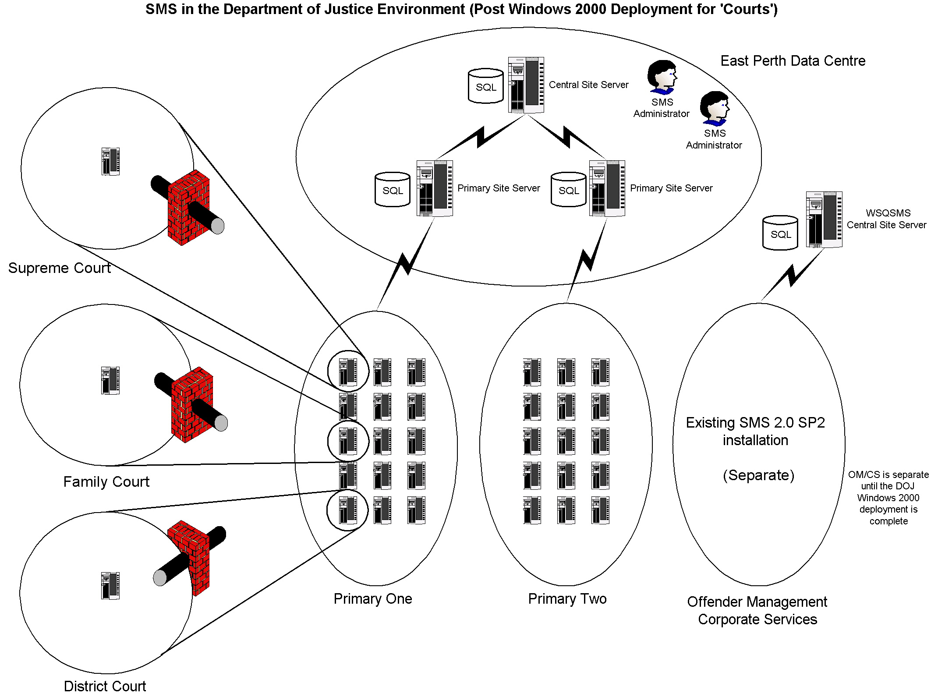
Figure 5.1 – SMS Hierarchy Structure (Pre OM W2K)

This design will not be final until after the Offender Management and Corporate Services sites have been migrated to Windows 2000. A diagram of this design is presented below and will be discussed in detail in the follow-up document Integration of Offender Management and Corporate Services into the DOJ SMS Environment.

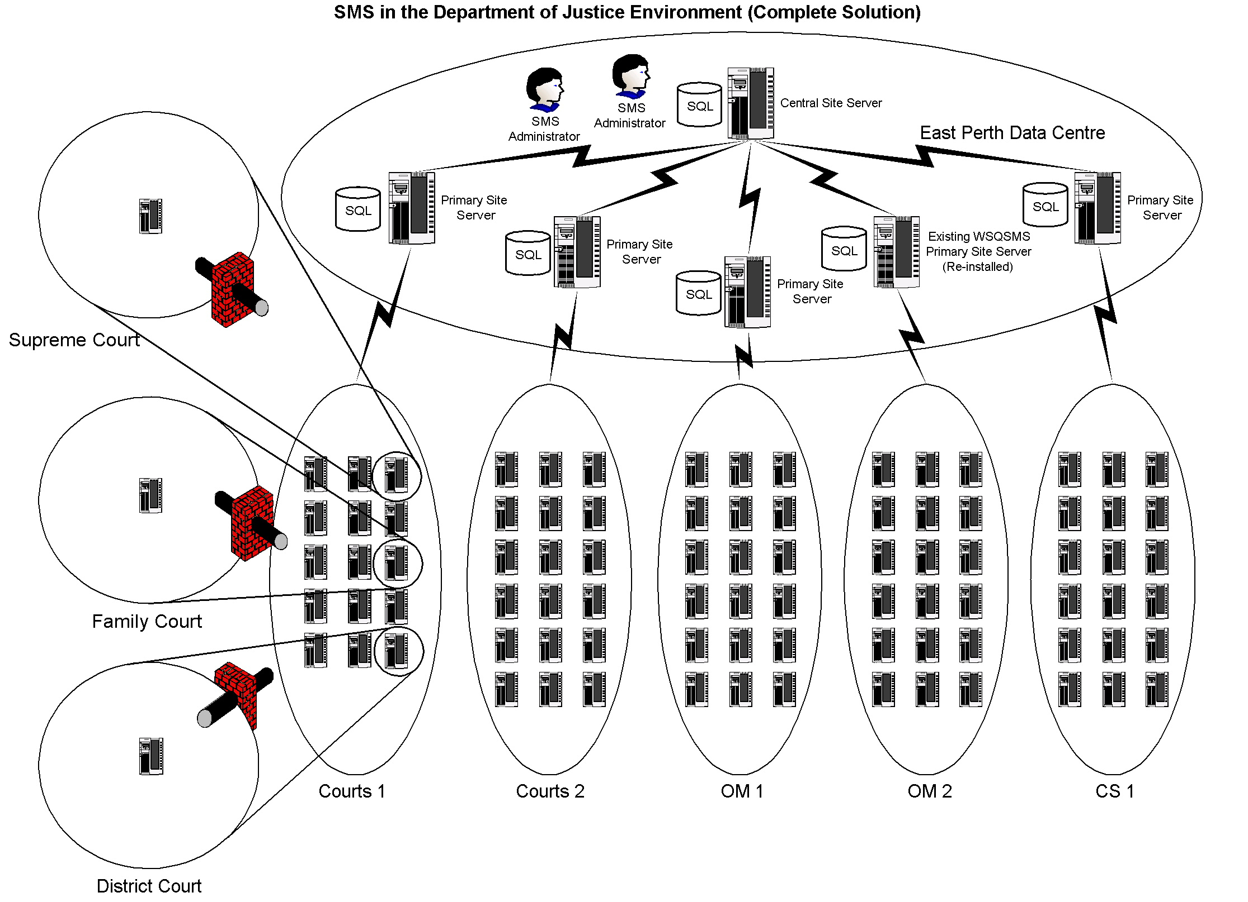
Figure 5.2 – SMS Hierarchy Structure (Post OM W2K)

Central Site Server

The most important server in any SMS installation is the central site server. This server houses data for the entire organisation and controls the operation of all child sites. As such, it must have sufficient hardware resources to do the job. A table showing minimum hardware specifications for site servers appears in Appendix B.

There already exists a functioning central site server that forms part of the SMS implementation for Offender Management. It currently has 38 secondary sites attached to it and houses data for 1900+ workstations/servers. It is feasible that this server could act as the central site server for the Courts SMS installation, but due to the timing of the OM Windows 2000 rollout, this is not possible.

Primary Site Servers

The primary site servers allocated to the Courts SMS installation will be the workhorses of the operation. They will process data from the secondary sites that report to them, and these are scattered throughout Western Australia. The Secondary Site Servers then pass their information to the central site server. They are also the control point for all their child sites as all configuration changes are routed through these sites.

At present, there are no servers available to take on this important role. Two servers will have to be purchased or allocated to fill this role. A table showing minimum hardware specifications for site servers appears in Appendix B.

Secondary Site Servers

Given the current network infrastructure, it is proposed that the Courts division will require 38 SMS secondary sites in order to service their 1000+ workstations. Each secondary site server will look after the clients within its site boundaries, and any change in client configuration will be routed through these site systems.

The secondary site servers do not have to be dedicated machines. Therefore, it is feasible that the existing resource servers could do the job. A table showing minimum hardware specifications for site servers appears in Appendix B.

Site Server Locations

The following table outlines the Courts SMS sites.

Site Name | Site Type | Parent Site | Site Code
Central Site | Central | N/A | ZZZ
Primary One | Primary | Central Site | P01
Primary Two | Primary | Central Site | P02
Albany Court | Secondary | Primary Two | S01
Armadale Court | Secondary | Primary One | S02
Victim Support Services | Secondary | Primary One | S03
Broome Court | Secondary | Primary Two | S04
Bunbury Court | Secondary | Primary Two | S05
Busselton Justice Complex | Secondary | Primary Two | S06
Carnarvon Court | Secondary | Primary One | S07
Children’s Court | Secondary | Primary Two | S08
Collie Court | Secondary | Primary One | S09
Coroners Court | Secondary | Primary Two | S0A
Derby Court | Secondary | Primary One | S0B
District Court | Secondary | Primary One | S0C
Esperance Court | Secondary | Primary One | S0D
Family Court | Secondary | Primary Two | S0E
Fremantle Justice Complex | Secondary | Primary Two | S0F
Geraldton Court | Secondary | Primary Two | S10
Guardianship Board | Secondary | Primary Two | S11
Joondalup Court | Secondary | Primary Two | S12
Kalgoorlie Court | Secondary | Primary Two | S13
Katanning Court | Secondary | Primary One | S14
Karratha Court | Secondary | Primary Two | S15
Kununurra Court | Secondary | Primary One | S16
Mandurah Court | Secondary | Primary One | S17
Manjimup Court | Secondary | Primary One | S18
Magistrates Court | Secondary | Primary One | S19
Merredin Court | Secondary | Primary One | S1A
Midland Court | Secondary | Primary Two | S1B
Moora Court | Secondary | Primary One | S1C
Narrogin Court | Secondary | Primary One | S1D
Northam Court | Secondary | Primary Two | S1E
Parole Board | Secondary | Primary Two | S1F
Pinjarra Court | Secondary | Primary One | S20
Port Hedland Justice Complex | Secondary | Primary Two | S21
Rockingham Justice Complex | Secondary | Primary Two | S22
Roebourne Court | Secondary | Primary One | S23
Small Claims Tribunal | Secondary | Primary One | S24
Supreme Court/AXA Building | Secondary | Primary Two | S25
Table 5.2 – Site Server Locations

Site Hierarchy Diagrams

For diagrams showing the proposed SMS site structure for Courts, see Appendix A.

SMS Features

It is proposed that the following SMS facilities will be implemented:

- Hardware Inventory
- Software Inventory
- Software Distribution
- Remote Tools

Licence metering is not seen as an immediate objective, and should not be considered at this stage as a large amount of additional hardware would be required.

SMS Site System Roles

SMS is comprised of several modules or site systems that interact with each other to form the complete product. This modularity allows SMS to be a distributed system, with different site systems residing on multiple disk partitions or even multiple servers. The main system roles are outlined below:

- Site Server – a set of shared file systems and services that interact to provide the core functions of a SMS installation.
- Client Access Point – a shared file system that acts as a connection point for client workstations/servers. Inventory data is passed from the client to the CAP, and configuration information is passed from the CAP to the client. It also contains the files required for the SMS client installation process.
- Logon Point – a shared file system from which the SMS client installation is initiated when using the Windows Logon Installation method. It is also involved in the SMS client discovery process.
- Distribution Point – a shared file system that acts as a repository for software packages that are to be distributed to client workstations via the SMS software distribution facility.

Server Roles for Courts SMS Servers

As indicated earlier, a single server can perform all site system roles, or they can be distributed amongst several servers. With the Courts SMS implementation, it is envisaged that all site servers will perform all system roles, as well as providing file and print sharing facilities, and possibly logon authentication duties. The table below outlines the system roles undertaken by the SMS site servers.

 | System Role
Server Type | Site Server | Client Access Point | Logon Point | Distribution Point
Central | ☑
Primary | ☑
Secondary | ☑ | ☑ | N/A¹ | ☑
Domain Controllers |  |  | N/A¹
Member Servers |  |  |  | ☑²
¹ Not applicable as Remote Client Installation will be used
² Possible distribution point
Table 5.3 – Site System Roles

Hardware Required for Server Roles

The Courts servers that have been targeted as potential SMS site servers will require additional resources beyond what is required for normal file and print operations. The following table outlines the resources that each system role requires for normal operation. These specifications are based on test results carried out in the test lab and the current SMS production environment. A summary of the test results can be found in Appendix G.

Site System Role | Minimum Resources Required
Central Site Server | Single 600MHz processor, 768MB RAM,24GB disk space (dedicated SMS server)
Primary Site Server | Single 600MHz processor, 512MB RAM, 24GB disk space (dedicated SMS server)
Secondary Site Server | Single 600MHz processor, 256M RAM, 9GB reserved disk space
Client Access Point | 64M RAM, 200MB reserved disk space
Logon Point | 64M RAM, 100MB reserved disk space
Distribution Point | 9GB reserved disk space
Table 5.4 – Hardware Resources for Server Roles

SMS Site Configuration

The following sections outline the properties to be assigned to Courts SMS sites. It must be stated that these are guidelines only, and must be more specifically defined using up-to-date information before implementation begins.

SMS Site Naming

Each SMS site must have a unique identifier associated with it. This identifier is in the form of a three-character code and is referred to as the SMS site code. It is also possible to assign a text site name and description to each site.

SMS Site Boundaries

Site boundaries are vital to the operation of SMS because they determine which workstations belong to which site. The boundaries are defined as IP subnets and this information is passed to all logon points. When a workstation attempts to become a SMS client, its IP address is checked against the site boundaries of every site. If it conforms to a boundary, it is assigned to that site and the installation process continues. If a workstation is not assigned, the client installation process will fail to complete.

It is proposed that only secondary sites will have boundaries assigned. Some Courts secondary sites will have more than one site boundary to accommodate additional subnets at that same physical location. It should be noted that SMS site boundaries do not function correctly if zero-subnets are used. Therefore, the Courts network structure must not utilise zero-subnet addresses.

A full list of proposed site boundaries can be found in Appendix C.

SMS User Accounts

SMS requires multiple user accounts in order to function normally. Some of these are generated during installation and should not be tampered with, some can be adjusted and some are optional.

Whilst most of the client service accounts are created locally, the accounts generated when a domain controller installs the SMS client will have domain scope. This is a direct result of the domain architecture and is unavoidable.

Other than the set of default accounts, additional accounts must be manually created. This is to ensure maximum functionality whilst maintaining a high degree of security. The following table outlines the additional accounts required.

Account Type | Number Required
Client Installation | 1 per site
Client Connection | 3 per site
LAN Sender | 1 per site
Table 5.5 Additional SMS Accounts

A table of SMS accounts is available in Appendix E.

Network Discovery

Network Discovery will be used to discover devices on each of the Courts network segments. The data gathered will be used by the Remote Client Installation process to install the SMS client onto servers. In order to discover new devices as they are added to the network, it is important that network discovery runs on a weekly basis.

Details of network discovery scheduling are outlined in Appendix E.

Client Installation

SMS provides two (2) automated methods for installing client software – Remote Client Installation and Windows Logon Installation. Both methods have advantages and disadvantages. These are detailed in the table below.

Installation Method | Advantages | Disadvantages
Remote Client | Easy to configure and maintain | Client installation can take up to the length of the discovery interval to commence
Remote Client | Client can be installed when no one is logged on | Workstations who have their client uninstalled will not receive a new install (Q253994)
Windows Logon | Client can be installed immediately by logging on | Reasonable complexity involved in configuration and maintenance
Windows Logon | More control over the installation process | Requires a logon to initiate client installation
Windows Logon |  | Execution via Policy assigned Logon Script does not work. Assignment via User Properties – Logon Script (as per Windows NT) does work.
Table 5.6 – Characteristics of SMS Client Installation Methods

To make the most of the advantages of each installation methods, both techniques will be employed. Remote Client Installation will be used to install the client software on servers and Windows Logon Installation (assigned via user properties) will be used to perform the same task on workstations. Site system servers will be installed via the WINNT Server Discovery mechanism (runs daily).

Client Configuration for Workstations

It is possible to configure each client agent as it is installed onto the workstations. The table below shows proposed configuration for the agents that are going to be used in the Courts SMS deployment. These settings are for workstations only.

SMS Agent | Global Configuration
Client Discovery | Logon discovery will not be used as it generates too much network traffic
Heartbeat Discovery | Heartbeat discovery will have a refresh interval of one week. This refreshes information in the SMS database and has minimal impact on the client machines.
Remote Client Installation | Remote Client Installation will be used to install client software. It works by utilising DDR’s that are generated during the network discovery process.
Hardware Inventory | Hardware inventory will be configured to run once a week (full scheduling).
Software Inventory | Software inventory will be configured to run once a week (full scheduling).
Table 5.6 – Client Configuration for Workstations

Details of hardware and software inventory scheduling are outlined in Appendix D.

Client Configuration for Servers

The SMS client software can be installed on servers and functions in the same way as on workstations. The table below shows the proposed configuration for the agents that are going to be used in the Courts SMS deployment.

SMS Agent | Global Configuration
Client Discovery | Logon discovery will not be used as it generates too much network traffic
Heartbeat Discovery | Heartbeat discovery will have a refresh interval of one week. This refreshes information in the SMS database and has minimal impact on the client machines.
Client Installation | Windows NT SMS Server Discovery will initiate the client installation for servers that are SMS site systems. Remote Client Installation will be used for servers that are not SMS site systems.
Hardware Inventory | Hardware inventory will be configured to run once a week (full scheduling).
Software Inventory | Software inventory will be configured to run once a week (full scheduling).
Table 5.7 – Client Configuration for Servers

Details of hardware and software inventory scheduling are outlined in Appendix D.

SMS Site System Configuration

All SMS sites have various settings that can be configured. The following table outlines proposed settings for the Courts SMS sites.

SMS Site Server
Property | Value
SMS Service Account | SMS service account created for site (see Appendix D)
SMS Client Installation Account | SMS client installation account created for site. It will default to the SMS service account upon failure (see Appendix D)
SQL Server Account | Only used at the central and primary sites
Parent Site | All sites will be set to the site code of their respective primary site (see Appendix C)
Boundaries | Will be set to the list of IP subnets in use at the site (see Appendix C)
SMS Site Server Installation Directory | Local drive D:\SMS
Status Message Replication | Once per hour (default)
SMS Client Access Point
No changes will be made to the default configuration
SMS Logon Point
Windows Logon Installation will not be used
SMS Distribution Point
Property | Value
SMS Distribution Point Directory | Local drive. Note that this only important if software distribution is going to be implemented.
Table 5.8 – Site System Configuration

Inter-site Communication

For SMS to function correctly, it must be able to communicate freely between installed site servers. This communication path allows the transferral of data from secondary sites to primary sites and vice-versa. Common data transferral includes discovery data, inventory data, client configuration information and site control files.

SMS uses the concepts of Addresses and Senders to create a communication path between sites. For two sites to communicate with each other, they must have an address for the other site, and a sender.

An Address has the following attributes:

- Destination SMS site code
- Destination server name
- Windows account to use for access
- Priority level
- Optional schedule for restricting network access
- Optional rate limits for restricting network usage

An address will be created at the primary site for each of the secondary sites, and each secondary site will have one address for the primary site. Each address can be configured to control the amount of bandwidth that SMS uses.

The SMS messaging system can be configured to perform inter-site replication at different priority levels – low, medium and high. For example, site control files can be replicated at high priority and status messages at medium priority. It is proposed that the working day be divided into high and low priority periods, based on probable network usage. During the high usage periods, only high and medium priority SMS data will be transferred between sites, and during the low usage periods, all priorities will be replicated. This essentially means that any server–to-server traffic will replicate during work hours, but client data will only be transferred after hours. The priority periods are shown below:

Start Time | End Time | Priority Classification
8am | 5pm | High
5pm | 10pm | Low
10pm¹ | 12am | High
12am | 8am | Low
¹ Backup period
Table 5.9 – Priority Periods
SMS has five types of sender that can be used to transport data between sites. These are:

- Standard (LAN)
- Asynchronous RAS
- ISDN RAS
- X25 RAS
- SNA RAS

It is proposed to use the Standard Sender to connect sites in the Courts SMS implementation.

SMS Security

Security for the Court SMS implementation can be broken down into three categories – domain security, SQL database security and operational security. These are discussed in the following sections. General information concerning passwords is given in section 5.5.4.

Domain Security

Windows domain and machine security is addressed through Windows accounts – both domain and local. A list of the proposed accounts to be used in the Courts SMS deployment can be found in Appendix D. These accounts attempt to comply with the security requirements of the Department of Justice, as well as to balance a high level of security against the complexity of administration tasks.

During the Courts rollout, it is planned to have all resources in a single domain that will have a joint logon and resource role. With this in mind, there are two approaches to domain security.

These are:

- Create a single domain-wide account that has access to all workstations and servers. This approach would be easy to implement and would reduce the complexity of administrative tasks, but it would have global implications if a security breach were to occur.
- Create a separate account per SMS site that has access only to the resources within the respective site boundaries. This approach contains the damage if a security breach occurs, but it makes administrative tasks exceedingly complex.

It has been decided that the single account approach be taken, but this can be revisited when the security model for the rollout has been agreed upon.

SQL Database Security

The proposed SMS hierarchy for the Courts division includes multiple primary site servers. These servers will have an installation of SQL Server 2000 which is used to store data from all resources in the SMS structure. SMS uses a single SQL Server account to access the SQL database at a primary site. This is usually set to the SA account during SMS installation, but it can be changed afterwards. To enable SQL Server 2000 inter-operability with SMS, Mixed Mode Authentication must be used.

SMS Operational Security

SMS is administered and configured through the SMS Administration Console, which is a snap-in for the Microsoft Management Console (MMC). The console has an ‘object’ security model which allows security to be applied at a task level. An example of this would be to ‘lock-down’ the ability of certain users to modify a particular query. This ‘object’ model gives the SMS administrator a very flexible and granular approach to operational security.
It is also possible to customise the MMC to display selected components of the SMS Administration Console. This means it is possible to configure consoles based on operational role. For example, if a staff member was assigned to software distribution, a console could be designed to show workstation collections and the packaging sections. Everything else would be hidden, making it impossible for the user to change vital site configuration parameters.

At this stage, four (4) levels of access for the Courts SMS implementation have been identified, and these are listed below. The finalisation of SMS support roles may uncover additional roles that may be added to this security design.

Function | Description
SMS Administrator | This resource undertakes the installation and maintenance of SMS, configures all properties and performs specific inventory operations. The SMS Administrator requires Full Control rights over every object in the SMS hierarchy.
Client Manager | This resource is the designated manager(s) for the Courts division. They may require access to SMS to keep a track on assets. The Client Manager role requires Read rights to objects in the SMS hierarchy.
Software Distribution | This resource creates and configures SMS packages and advertisements.
Remote Tools | This resource utilises the Remote Tools suite to perform support.
Table 5.10 – SMS Resource Functions

SMS Account Names and Password Changes

As a rule, the accounts and associated passwords used by SMS services should not be allowed to expire or be changed. Components using these accounts are numerous and can exist at multiple locations. An unauthorised password or account name change has a risk of failure associated with it, and any failure can result in SMS becoming inoperable.

However, it is possible to change the SMS Service account and the SQL Server account and retain full SMS functionality. If so desired, an agenda can be put in place to change the passwords of these accounts on a six-monthly basis. Changing SMS Passwords is not recommended, however the practise is supported by Microsoft.

User accounts created for SMS should have the Password Never Expires option checked.

SMS Resourcing

For the SMS deployment at Courts, the operational processes can be broken into several areas. These are expected to comprise of:

- Installation and configuration (deployment)
- Administration
- Database administration

Roles such as software packaging and distribution and helpdesk are not included at this time because these features are not to be deployed during the Courts SMS rollout.
The installation and configuration role is a temporary one and is operational until the deployment is complete. The time allocated to the software distribution role is only for the creation and configuration of SMS packages and advertisements. It does not take into account the following:

- Time taken to package the application from source
- Time taken to distribute the completed package
- Time taken for workstations to install software
- Time taken to clean up any failed installs

The SMS administration role is ongoing and is present for as long as the SMS installation is operational. Table 5.9 outlines staffing levels for the operational roles described above. These are estimates only and can be modified when more information is available.

Role | Time Required (Hours per Week) | Tasks
Deployment | 37.5, but only for the deployment phase | Installation and configuration of all SMS sites in the Courts division
SMS Administration | 30.0 ongoing (full-time resource) | Daily operation of SMS including SQL database maintenance, site server and client management, inventory processing and reporting, and backups.
Software Distribution | 2.0 per software distribution | Creation and configuration of SMS packages and advertisements.
Table 5.11 – SMS Required Resources

Additional software

The Crystal Reports software that is packaged with SMS is not sufficient to produce reports when greater than 500 clients are installed. Therefore, it is suggested that an additional reporting tool be implemented to produce standard and customised reports.

There is a utility called the SMS Web Reporting Tool that is free and has already been implemented in the OM SMS installation. This is a web-based tool (using Microsoft Internet Information Server) and has proved to be excellent for producing quality reports. It is proposed that this tool be used with the Courts SMS deployment.

RECOMMENDATIONS AND TASKS REQUIRED FOR SMS DEPLOYMENT

This section presents some recommendations with regard to the reliable operation of SMS when it is deployed into the Courts environment. It also outlines the tasks required to complete the Courts SMS implementation.

Recommendations

The following sub-sections summarise recommendations for the Courts network architecture. They are put forward as proposals only and are subject to further discussion.

Placement of Windows Domain Controllers

All sites will have a local domain controller. The only sites that may use a non-local domain controller are metro sites that are linked by high speed WAN connections e.g. East Perth Data Centre, though these are essentially LAN connections.

Tasks Required

Based on the assumptions that there will be no major change to the planned Courts infrastructure and that the recommendations given above are adopted, the following is a list of tasks that are required to be completed in order to successfully deploy SMS into the Courts division. These should be viewed as a series of tasks, with the start of each being dependent on the successful completion of the previous.

Finalising SMS Design

A number of areas covered by the original SMS design (section 5.0) required further information and development before deployment could proceed. These are listed in the table below.

Design Area | Information and Work Required | Status
SMS Server Design | Obtain server names, locations, functions and IP subnets | Complete
 | Finalise site coding | Complete
 | Develop a site server role plan | Complete
 | Obtain fixed disk and logical drive structures | Complete
 | Finalise reserved SMS logical drive and size | Complete
 | Verify time synchronisation | Complete
Windows Domain Design | Verify single domain structure | Complete
Windows Domain Design | Finalise naming and use of SMS accounts | Complete
Courts Network Design | Obtain IP addressing plan | Complete
Courts Network Design | Finalise SMS restrictions for WAN links | Complete
Courts Network Design | Develop SMS site addressing configuration | Complete
SMS Operation | Finalise inventory data to be collected | Complete
SMS Operation | Finalise SMS site configuration | Complete
SMS Operation | Finalise the reporting system including design of reports | In Progress
SMS Operation | Develop and document SMS operating procedures | In Progress
Table 6.1 – Finalising SMS Design

SMS Test Site

Before the Courts SMS design is deployed into the production environment, it was important to fully test the functionality of SMS in a test environment. The test lab mirrored the proposed production environment as closely as possible to get a true indication of SMS performance. Initially it was not possible to imitate the existence of WAN links, though this was able to be performed within the PIP Lab, essentially mirroring a 64Kb ISDN link.

The equipment used to build the test lab is as follows:

- One Windows 2000 server for use as a SMS central site server
- One Windows 2000 server for use as a SMS primary site server
- One Windows 2000 server for use as a SMS secondary site server
- Five Windows 2000 workstations for use as SMS clients
- One switch to provide network connectivity

The secondary site was configured as a domain controller and operated DHCP, DNS and WINS. The secondary site server had boundaries set for the site, and the primary site server acted purely as a data storage point.

The SMS test programme sought to accomplish the following:

- Test primary and secondary site installation processes
- Test Courts workstation SMS client installation methods
- Test Windows SMS Server Discovery
- Test SMS Network Discovery
- Test SMS Hardware Inventory process
- Test SMS Software Inventory process
- Obtain server ‘load signatures’ through performance monitoring
- Test SMS Performance over slow WAN Links (64Kb)
- Test SMS Remote Tools
- Test SMS Software Distribution

Appendix G contains a summary of the test results. A complete outline of the tests performed and a description of the outcomes can be found in the document Test Results for Courts SMS Design.

Finalisation of SMS Configuration and Procedures

Changes to the final configuration and procedures for the Courts SMS implementation were expected, and resulted from finalisation of the Courts infrastructure and the test exercises.

SMS Pilot

Small Claims Tribunal will be used as the SMS pilot site. This site has 8 users and operates a 64Kb WAN link to Central Law Courts. The pilot will take place over a one week period and all facets of the SMS feature set will be trialled. A breakdown of the sequence of events is shown below.

Task | Estimated Time
Primary site server installation | 1 day
Secondary site server installation | ½ day
Addition of site boundary, discovery and client installation | ½ day
Activation and testing of inventory agents | ½ day
Activation and testing of software distribution | 1 day
Activation and testing of remote tools | ½ day
Performance monitoring and UAT | 1 day
Table 6.2 – Pilot Site Tasks

The impact on users during the pilot will be considerable. User disturbance will be kept to a minimum where possible, but much of the testing requires liaison with the user population. The pilot project requires changes to be made to the onsite server and the client workstations. A risk assessment of these activities is outlined below.

Activity | Risk
Server Operations | Moderate
Workstation Operations | Low
Table 6.3 – Pilot Risk Assessment

SMS Deployment

As each Courts site is rolled out, SMS will be deployed at the same time. The process for a typical Courts site is summarised in the table below. Note that the tasks are listed in order of completion.

Order | Task | Person Responsible
1 | Completion of Courts SOE server | SOE Rollout Team
2 | Installation of SMS secondary site onto new server | SMS Administrator
3 | Completion of SOE workstation rollout | SOE Rollout Team
4 | Configure OM site boundaries at shared locations | SMS Administrator
5 | Enable Remote Client Installation at site | SMS Administrator
6 | Perform Network Discovery on local subnet | SMS Administrator
7 | Verify client installation on all workstations | SMS Administrator
8 | Activate and configure inventory agents | SMS Administrator
9 | Verify collection of inventory data | SMS Administrator
10 | Activate software distribution agent | SMS Administrator
11 | Verify software distribution function | SMS Administrator
12 | Activate remote tools suite | SMS Administrator
13 | Verify remote tools functionality | SMS Administrator
14 | Declare SMS operational at site | SMS Administrator
Table 6.4 – SMS Deployment Tasks

Ongoing SMS Operation

Once the Courts SMS deployment has been completed, SMS will be used by the Department of Justice for asset tracking, collection of inventory data, software distribution and remote management of the Courts division workstation/server fleet. To maintain and operate SMS effectively, dedicated resources need to be allocated to the project. Estimated required resourcing is shown below:

- SMS Administrator – full time position (30.0 hrs per week)
- Software Distribution – part time position (2.0 hrs per software package)

See Section 5.8 for a detailed discussion on this topic.

APPENDIX A – SMS HIERARCHY DIAGRAMS

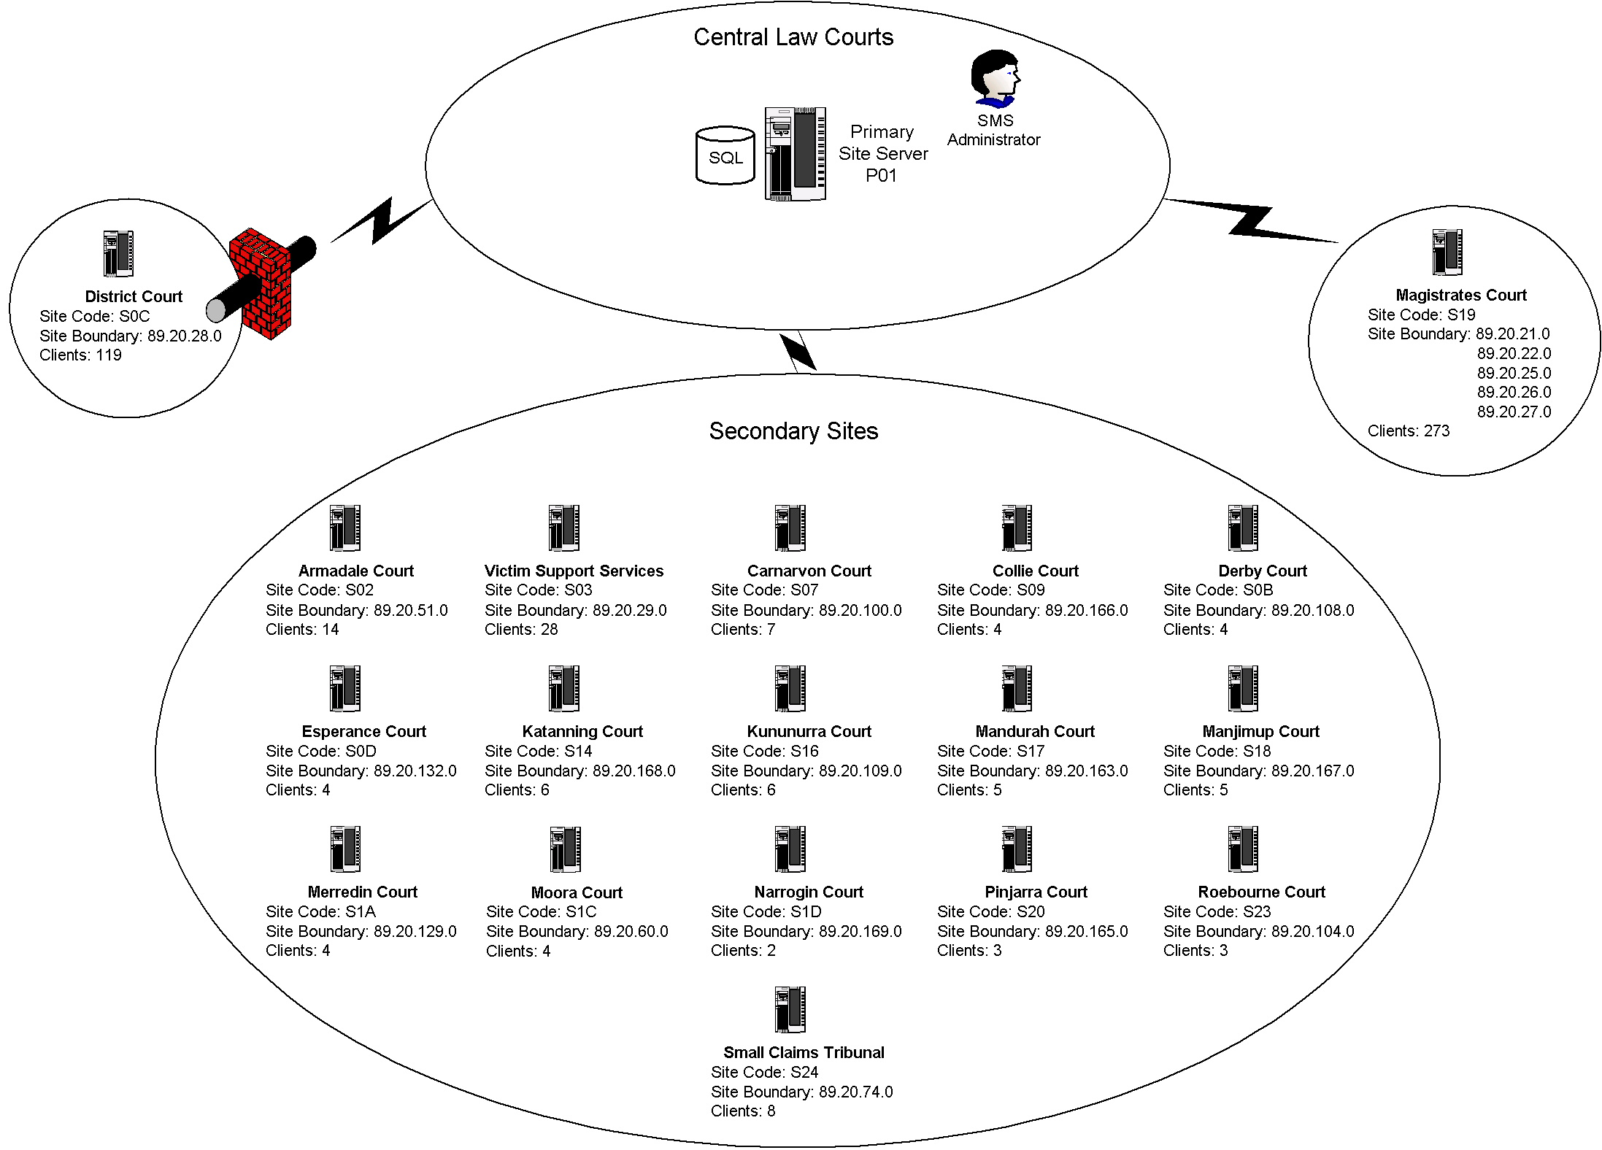
Figure A.1 – Primary One
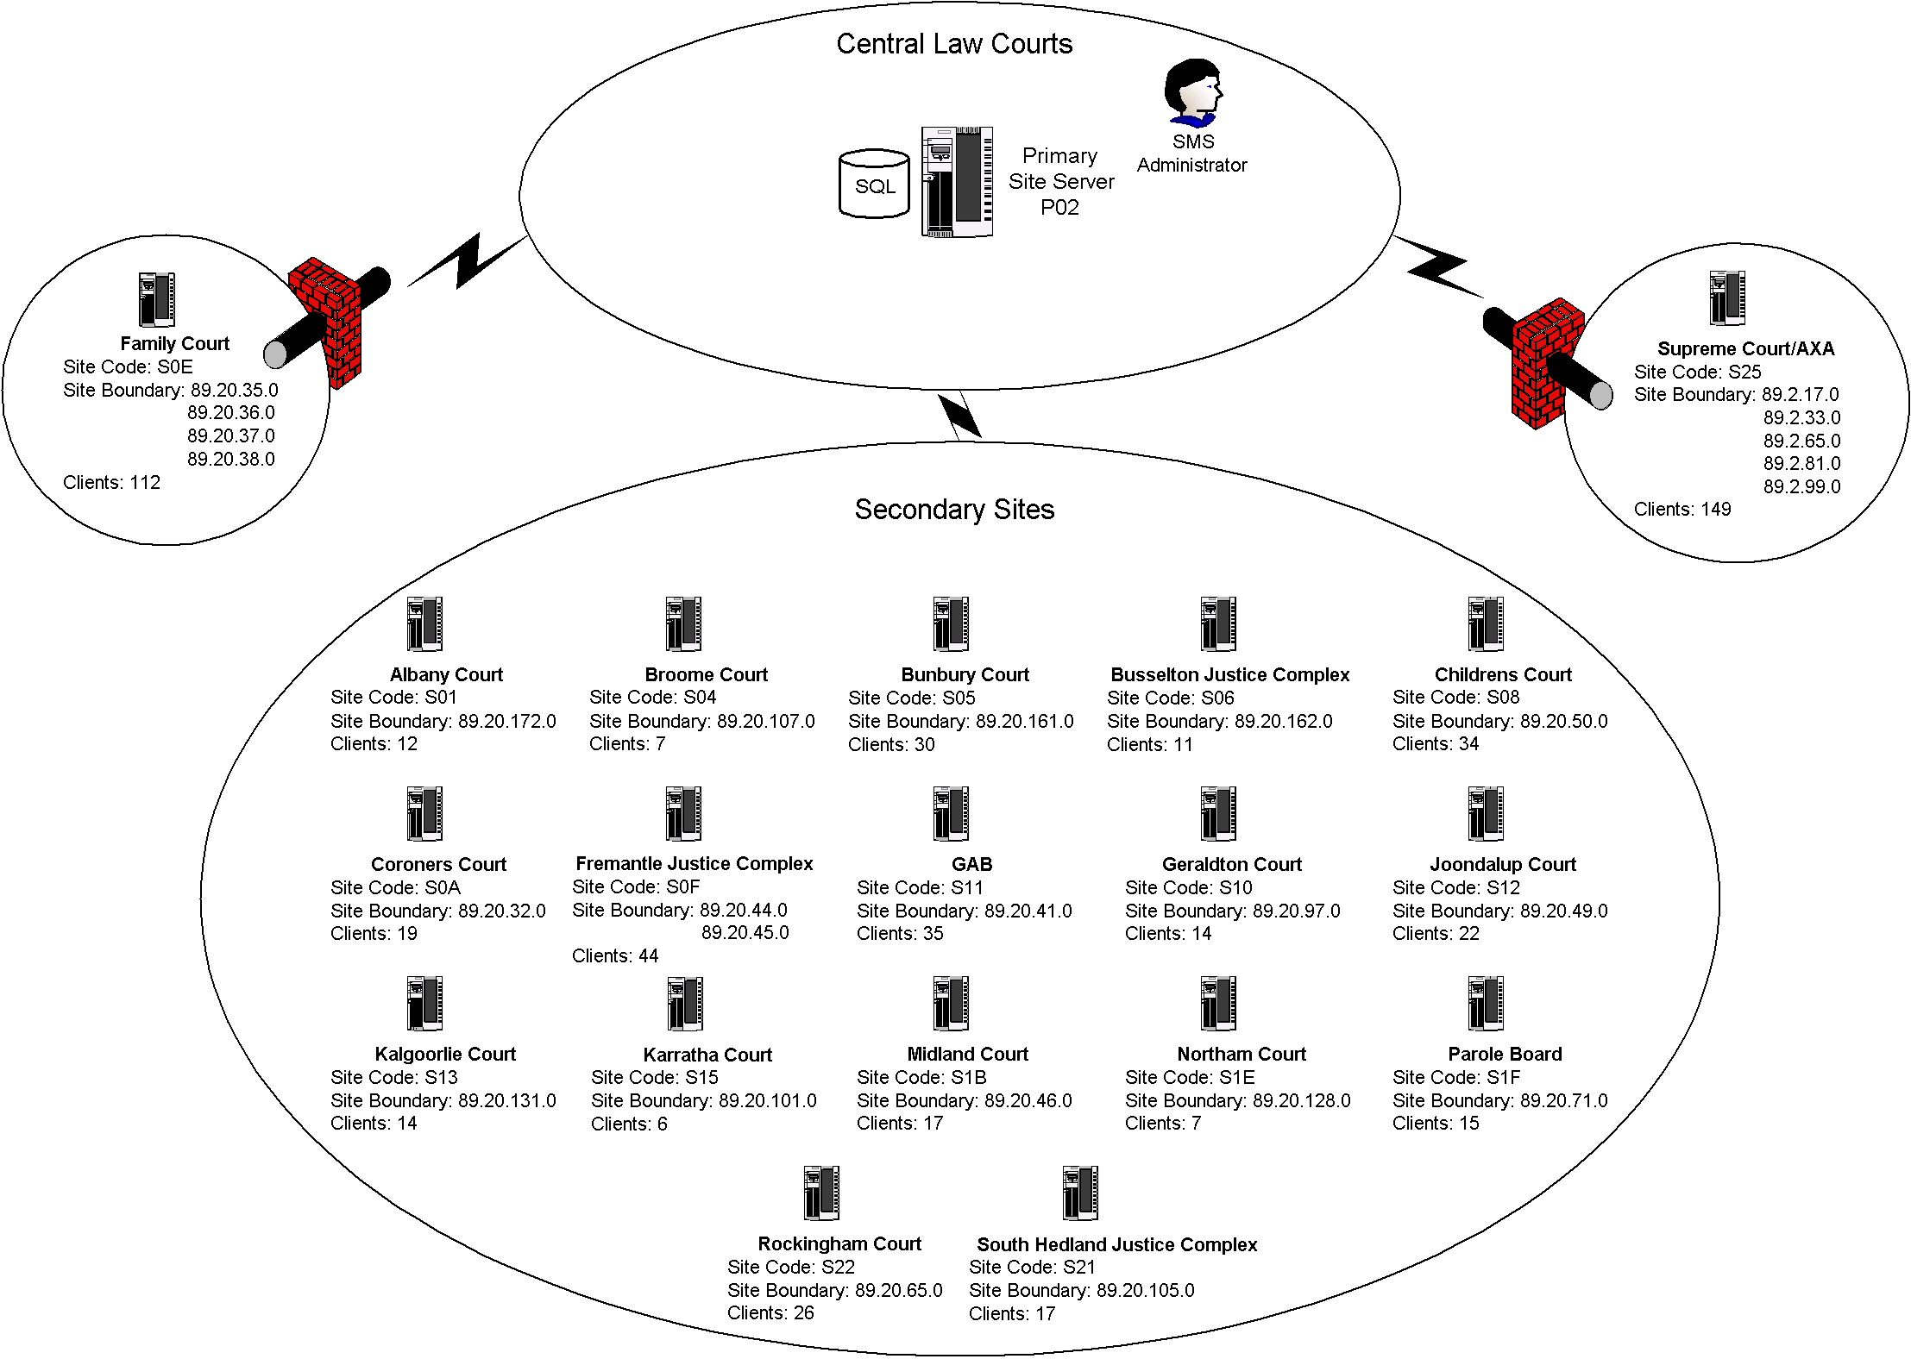
Figure A.2 – Primary Two
APPENDIX B – HARDWARE SPECIFICATIONS

The following hardware specifications have been derived from trials carried out in the test lab and the current SMS production environment. A summary of the test results can be found in Appendix G.

Central Site Server Hardware Specification

- Dual 600MHz Pentium III processors or equivalent
- 768GB of RAM
- 40GB of free fixed disk storage spread over at least three disks using hardware RAID 5
- Single 10/100MB network card, with option to add a second NIC
- Backup device capable of backing up the entire server

Primary Site Server Hardware Specification

- Single 600MHz Pentium III processor or equivalent
- 512MB of RAM
- 30GB of free fixed disk storage spread over at least three disks using hardware RAID 5
- Single 10/100MB network card, with option to add a second NIC
- Backup device capable of backing up the entire server

Secondary Site Server Hardware Specification

- Single 600MHz Pentium III processor or equivalent
- 256MB RAM
- 18GB of free fixed disk storage spread over at least three disks using hardware RAID 5
- Single 10/100MB network card, with option to add a second NIC
- Backup device capable of backing up the entire server

Client Workstation Hardware Specification

- Single 350MHz Pentium II processor or equivalent
- 15MB of dedicated RAM
- 15MB of free fixed disk space

Additional Specifications

The proposed Courts SMS design calls for no central or primary site to have site boundaries, and therefore no clients will be assigned to these servers. All client activity will be routed through the secondary sites, and thus, all secondary site servers must have the following specifications:

- Must run Windows 2000 Server or Advanced Server with Service Pack 2
- Must function as a Windows domain controller
- Must have sufficient memory to run all SMS services
- Must be able to support over 100 SMS client workstations
- Must be able to provide file and print services to over 100 workstations
Hardware configuration choices

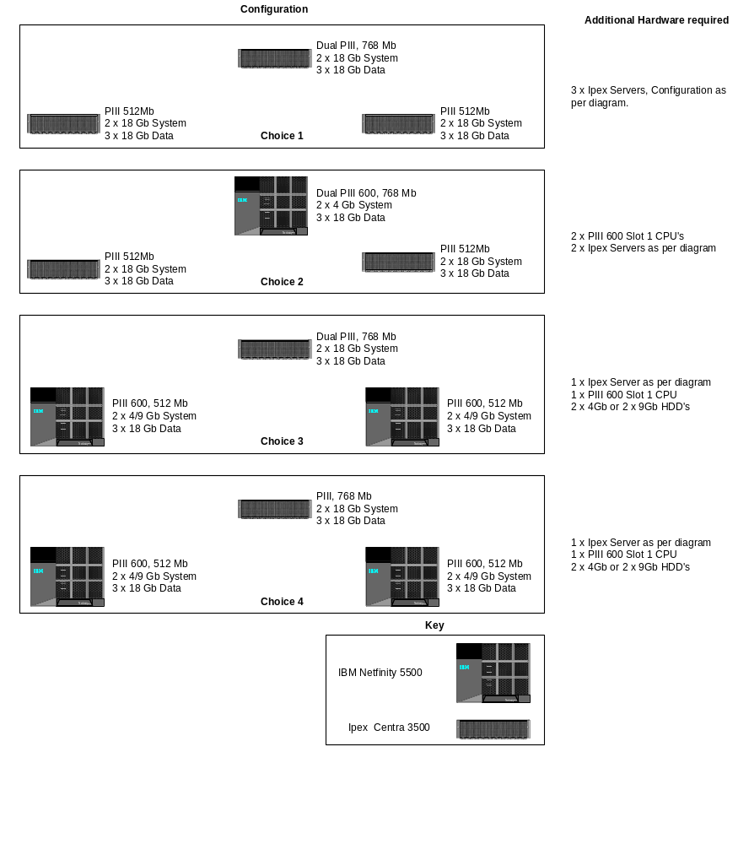

Configuration chosen for Courts

APPENDIX C – SMS SITE CONFIGURATION

Site Name | Site Type | Site Boundary (89.20.x.0) | Site Code
Central Site | Central | - | ZZZ
Primary One | Primary | - | P01
Primary Two | Primary | 2 | P02
Albany Court | Secondary | 172 | S01
Armadale Court | Secondary | 51 | S02
Victim Support Services | Secondary | 29 | S03
Broome Court | Secondary | 107 | S04
Bunbury Court | Secondary | 161 | S05
Busselton Justice Complex | Secondary | 162 | S06
Carnarvon Court | Secondary | 100 | S07
Children’s Court | Secondary | 50 | S08
Collie Court | Secondary | 166 | S09
Coroners Court | Secondary | 32 | S0A
Derby Court | Secondary | 108 | S0B
District Court | Secondary | 28 | S0C
Esperance Court | Secondary | 132 | S0D
Family Court | Secondary | 35 - 38 | S0E
Fremantle Justice Complex | Secondary | 44 – 45 | S0F
Geraldton Court | Secondary | 97 | S10
Guardianship Board | Secondary | 41 | S11
Joondalup Court | Secondary | 49 | S12
Kalgoorlie Court | Secondary | 131 | S13
Katanning Court | Secondary | 168 | S14
Karratha Court | Secondary | 101 | S15
Kununurra Court | Secondary | 109 | S16
Mandurah Court | Secondary | 163 | S17
Manjimup Court | Secondary | 167 | S18
Magistrates Court | Secondary | 21-22, 25-27 | S19
Merredin Court | Secondary | 129 | S1A
Midland Court | Secondary | 46 | S1B
Moora Court | Secondary | 60 | S1C
Narrogin Court | Secondary | 169 | S1D
Northam Court | Secondary | 128 | S1E
Parole Board | Secondary | 71 | S1F
Pinjarra Court | Secondary | 165 | S20
Port Hedland Justice Complex | Secondary | 105 | S21
Rockingham Justice Complex | Secondary | 65 | S22
Roebourne Court | Secondary | 104 | S23
Small Claims Tribunal | Secondary | 74 | S24
Supreme Court/AXA Building | Secondary | 89.2.17.0 | S25
 |  | 89.2.33.0
 |  | 89.2.65.0
 |  | 89.2.81.0
 |  | 89.2.99.0
Table C.1 – SMS Site Configuration
APPENDIX D – HARDWARE AND SOFTWARE INVENTORY SCHEDULING

Location | Site Code | Hardware | Software
Primary One | P01 | Mon 10:00 AM | Mon 10:30 AM
Albany Court | S01 | Thurs 11:00 AM | Thurs 11:30 AM
Armadale Court | S02 | Mon 10:00 AM | Mon 10:30 AM
Victim Support Services | S03 | Mon 10:00 AM | Mon 10:30 AM
Broome Court | S04 | Thurs 11:00 AM | Thurs 11:30 AM
Bunbury Court | S05 | Wed 11:00 AM | Wed 11:30 AM
Busselton Justice Complex | S06 | Thurs 11:00 AM | Thurs 11:30 AM
Carnarvon Court | S07 | Mon 10:00 AM | Mon 10:30 AM
Children's Court | S08 | Wed 11:00 AM | Wed 11:30 AM
Collie Court | S09 | Mon 10:00 AM | Mon 10:30 AM
Coroners Court | S0A | Thurs 11:00 AM | Thurs 11:30 AM
Derby Court | S0B | Mon 10:00 AM | Mon 10:30 AM
District Court | S0C | Fri 10:00 AM | Fri 10:30 AM
Esperance Court | S0D | Mon 10:00 AM | Mon 10:30 AM
Family Court | S0E | Mon 11:00 AM | Mon 11:30 AM
Fremantle Justice Complex | S0F | Wed 11:00 AM | Wed 11:30 AM
Geraldton Court | S10 | Thurs 11:00 AM | Thurs 11:30 AM
Guardianship and Administration Board | S11 | Thurs 11:00 AM | Thurs 11:30 AM
Joondalup Court | S12 | Fri 11:00 AM | Fri 11:30 AM
Kalgoorlie Court | S13 | Fri 11:00 AM | Fri 11:30 AM
Katanning Court | S14 | Mon 10:00 AM | Mon 10:30 AM
Karratha Court | S15 | Fri 11:00 AM | Fri 11:30 AM
Kununurra Court | S16 | Thurs 10:00 AM | Thurs 10:30 AM
Mandurah Court | S17 | Thurs 10:00 AM | Thurs 10:30 AM
Manjimup Court | S18 | Thurs 10:00 AM | Thurs 10:30 AM
Magistrates Court | S19 | Wed 10:00 AM | Wed 10:30 AM
Merredin Court | S1A | Thurs 10:00 AM | Thurs 10:30 AM
Midland Court | S1B | Fri 11:00 AM | Fri 11:30 AM
Moora Court | S1C | Thurs 10:00 AM | Thurs 10:30 AM
Narrogin Court | S1D | Thurs 10:00 AM | Thurs 10:30 AM
Northam Court | S1E | Fri 11:00 AM | Fri 11:30 AM
Parole Board | S1F | Fri 11:00 AM | Fri 11:30 AM
Pinjarra Court | S20 | Thurs 10:00 AM | Thurs 10:30 AM
Port Hedland Justice Complex | S21 | Fri 11:00 AM | Fri 11:30 AM
Rockingham Court | S22 | Fri 11:00 AM | Fri 11:30 AM
Roebourne Court | S23 | Thurs 10:00 AM | Thurs 10:30 AM
Small Claims Tribunal | S24 | Thurs 10:00 AM | Thurs 10:30 AM
Supreme Court/AXA Building | S25 | Tue 11:00 AM | Tue 11:30 AM
Table D.1 – Inventory Scheduling
APPENDIX E – Network Discovery Schedule

Site Code | Schedule
ZZZ | N/A
P01 | Mon 12:00 AM
P02 | N/A
S01 | Fri 12:00 PM
S02 | Tue 12:00 PM
S03 | Tue 12:00 PM
S04 | Fri 12:00 PM
S05 | Thurs 12:00 PM
S06 | Wed 12:00 PM
S07 | Tue 12:00 PM
S08 | Thurs 12:00 PM
S09 | Tue 12:00 PM
S0A | Fri 12:00 PM
S0B | Tues 12:00 PM
S0C | Mon 12:00 PM
S0D | Tue 12:00 PM
S0E | Tue 12:00 PM
S0F | Thurs 12:00 PM
S10 | Fri 12:00 PM
S11 | Fri 12:00 PM
S12 | Mon 12:00 PM
S13 | Mon 12:00 PM
S14 | Tue 12:00 PM
S15 | Mon 12:00 PM
S16 | Fri 12:00 PM
S17 | Fri 12:00 PM
S18 | Fri 12:00 PM
S19 | Thurs 12:00 PM
S1A | Fri 12:00 PM
S1B | Mon 12:00 PM
S1C | Fri 12:00 PM
S1D | Fri 12:00 PM
S1E | Mon 12:00 PM
S1F | Mon 12:00 PM
S20 | Fri 12:00 PM
S21 | Thurs 12:00 PM
S22 | Thurs 12:00 PM
S23 | Fri 12:00 PM
S24 | Fri 12:00 PM
S25 | Wed 12:00 PM
Table E.1 – Network Discovery Schedule
APPENDIX F – SMS ACCOUNTS

The following table shows the base SMS accounts. The SMS service account is created during installation, but its name and password can be specified. All other accounts except the SMS Remote Client Installation account are automatically generated.

Account Name | SMS Account Name | Tasks | Rights
svcSMS | SMS Service account | Used by SMS services to access SMS site systems in a SMS site | Local administrator, log on as a service – on SMS site servers and CAP’s
SMSServer_xxx | SMS Server Network Connection account | Used by a number of SMS site services to access the SMS site server. Used by SMS site server services to access SMS site systems if the SMS Service account fails | Read permission to the \SMS directory, domain user, full control to the SMS_SITE share on the site server, permission to write DDR’s
SMSAddress_xxx | SMS Site Address account | Used to establish communications between SMS sites | Read, write, execute and delete permissions to the \Inboxes\Despooler.box on the destination SMS site server
SMSClient_xxx | SMS Client Network Connection account | Used by clients to connect to CAP’s and distribution points, transfer data and retrieve configuration settings | Read permission on CAP’s, logon points, write permission to the inboxes on CAP’s and logon points
SMS&_domain_controller_name | Client Services DC account | Run client services on domain controllers | Log on as a service, Act as part of the operating system, Replace a process level token
SMSCliSvcAcct& | Client services non-DC account | Run client services on non domain controllers | Local administrator, Log on as a service, Act as part of the operating system, Replace a process level token
SMSCliTokAcct& | Client token account | Creates user tokens on client computers | -
svcSMSInstall | SMS Remote Client Installation Account | Used by SMS site services to remotely install the SMS client onto workstations | Local administrator on target workstations, log on as a service – on SMS site servers and CAP’s
Table E.1 – SMS Default Accounts
The following table outlines the additional accounts required. The creation of these accounts ensures maximum SMS functionality whilst maintaining a high level of security.

Site Code | Client Connection Account 1 | Client Connection Account 2 | LAN Sender Account
ZZZ | N/A | N/A | svcSMSSender_ZZZ
P01 | N/A | N/A | svcSMSSender_P01
P02 | N/A | N/A | svcSMSSender_P02
S01 | svcSMSClient_S01_A | svcSMSClient_S01_B | svcSMSSender_S01
S02 | svcSMSClient_S02_A | svcSMSClient_S02_B | svcSMSSender_S02
S03 | svcSMSClient_S03_A | svcSMSClient_S03_B | svcSMSSender_S03
S04 | svcSMSClient_S04_A | svcSMSClient_S04_B | svcSMSSender_S04
S05 | svcSMSClient_S05_A | svcSMSClient_S05_B | svcSMSSender_S05
S06 | svcSMSClient_S06_A | svcSMSClient_S06_B | svcSMSSender_S06
S07 | svcSMSClient_S07_A | svcSMSClient_S07_B | svcSMSSender_S07
S08 | svcSMSClient_S08_A | svcSMSClient_S08_B | svcSMSSender_S08
S09 | svcSMSClient_S09_A | svcSMSClient_S09_B | svcSMSSender_S09
S0A | svcSMSClient_S0A_A | svcSMSClient_S0A_B | svcSMSSender_S0A
S0B | svcSMSClient_S0B_A | svcSMSClient_S0B_B | svcSMSSender_S0B
S0C | svcSMSClient_S0C_A | svcSMSClient_S0C_B | svcSMSSender_S0C
S0D | svcSMSClient_S0D_A | svcSMSClient_S0D_B | svcSMSSender_S0D
S0E | svcSMSClient_S0E_A | svcSMSClient_S0E_B | svcSMSSender_S0E
S0F | svcSMSClient_S0F_A | svcSMSClient_S0F_B | svcSMSSender_S0F
S10 | svcSMSClient_S10_A | svcSMSClient_S10_B | svcSMSSender_S10
S11 | svcSMSClient_S11_A | svcSMSClient_S11_B | svcSMSSender_S11
S12 | svcSMSClient_S12_A | svcSMSClient_S12_B | svcSMSSender_S12
S13 | svcSMSClient_S13_A | svcSMSClient_S13_B | svcSMSSender_S13
S14 | svcSMSClient_S14_A | svcSMSClient_S14_B | svcSMSSender_S14
S15 | svcSMSClient_S15_A | svcSMSClient_S15_B | svcSMSSender_S15
S16 | svcSMSClient_S16_A | svcSMSClient_S16_B | svcSMSSender_S16
S17 | svcSMSClient_S17_A | svcSMSClient_S17_B | svcSMSSender_S17
S18 | svcSMSClient_S18_A | svcSMSClient_S18_B | svcSMSSender_S18
S19 | svcSMSClient_S19_A | svcSMSClient_S19_B | svcSMSSender_S19
S1A | svcSMSClient_S1A_A | svcSMSClient_S1A_B | svcSMSSender_S1A
S1B | svcSMSClient_S1B_A | svcSMSClient_S1B_B | svcSMSSender_S1B
S1C | svcSMSClient_S1C_A | svcSMSClient_S1C_B | svcSMSSender_S1C
S1D | svcSMSClient_S1D_A | svcSMSClient_S1D_B | svcSMSSender_S1D
S1E | svcSMSClient_S1E_A | svcSMSClient_S1E_B | svcSMSSender_S1E
S1F | svcSMSClient_S1F_A | svcSMSClient_S1F_B | svcSMSSender_S1F
S20 | svcSMSClient_S20_A | svcSMSClient_S20_B | svcSMSSender_S20
S21 | svcSMSClient_S21_A | svcSMSClient_S21_B | svcSMSSender_S21
S22 | svcSMSClient_S22_A | svcSMSClient_S22_B | svcSMSSender_S22
S23 | svcSMSClient_S23_A | svcSMSClient_S23_B | svcSMSSender_S23
S24 | svcSMSClient_S24_A | svcSMSClient_S24_B | svcSMSSender_S24
S25 | svcSMSClient_S25_A | svcSMSClient_S25_B | svcSMSSender_S25
Table E.2 Additional SMS Accounts

All passwords will have a password length of 16 characters and will be randomly generated by a password utility.
appendix G – summary of test results

The following is a summary of the testing that was carried out to confirm the soundness of the Court SMS design. The testing was broken into two (2) sections – proof-of-concept and load simulation. The proof-of-concept trials were designed to verify the functionality of the SMS design, and the load simulation tests were intended to determine the amount of system resources that SMS would use under a variety of conditions.

Proof of concept

Function Tested | Result | Comments
Installation of Primary Site Server | Successful | All services were installed and functioned correctly.
Installation of Secondary Site Server | Successful | All services were installed and functioned correctly.
Parent-Child Relationships | Successful | Information from child site was successfully passed to the parent site. Child site appeared in the site hierarchy.
Network Discovery | Successful | Network devices were discovered and information was written to the SMS database
Client Installation Methods | Successful | The client software was successfully installed using all four (4) methods.
Inventory Methods | Successful | Inventory agents successfully extracted information from test machines and the data was stored in the SMS database
Software Distribution | Successful | Software packages were successfully deployed to test machines.
Remote Tools | Successful | The Remote Tools suite was used to control a test machine.
Reporting Methods | Successful | Crystal Reports and SMS Web Reporting Tool proved capable of delivering quality reports.
Password Interoperability with Windows NT | Successful | All SMS passwords must be limited to 14 characters.
Table G.1 – Proof-of-Concept Summary

Load simulation

The following tables show figures for a baseline test and a worst-case simulated load test on the central and primary site servers.

Counter | Minimum | Average | Maximum
Committed Bytes | 150138880 | 173338281 | 188551168
Pages/sec (Memory) | 0.000 | 0.71 | 64.334
% Usage (Paging) | 1.206 | 1.570 | 1.658
% Processor (smsexec) | 0.000 | 0.423 | 72.396
% Processor (sqlservr) | 0.000 | 0.934 | 79.167
Private Bytes | 7094272 | 7552949.110 | 8867840
Private Bytes | 44695552 | 63813045.090 | 75116544
% Processor (Total) | 0.518 | 8.810 | 100.000
Processor Queue Length | 1.000 | 2.042 | 12.000
Table G.2 – Central Site Server Baseline (Netfinity 5500)

Counter | Minimum | Average | Maximum
Committed Bytes | 141635584 | 142844638 | 143900672
Pages/sec (Memory) | 0.000 | 0.651 | 48.337
% Usage (Paging) | 3.243 | 3.511 | 4.190
% Processor (smsexec) | 0.000 | 0.101 | 19.792
% Processor (sqlservr) | 0.000 | 0.130 | 63.542
Private Bytes | 6901760 | 7240597 | 7491584
Private Bytes | 37109760 | 37589302 | 37965824
% Processor (Total) | 0.000 | 0.308 | 81.250
Processor Queue Length | 1.000 | 1.778 | 7.000
Table G.3 – Primary Site Server Baseline (IPEX Basic)

Counter | Minimum | Average | Maximum
Committed Bytes | 617541632 | 626392991 | 648916992
Pages/sec (Memory) | 0.000 | 0.445 | 32.000
% Usage (Paging) | 12.385 | 12.506 | 12.516
% Processor (smsexec) | 0.000 | 27.723 | 78.125
% Processor (sqlservr) | 0.000 | 12.924 | 48.438
Private Bytes (smsexec) | 9560064 | 9683760 | 9998336
Private Bytes (sqlservr) | 360030208 | 368097784 | 390152192
% Processor (Total) | 0.518 | 49.524 | 100.000
Processor Queue Length | 1.000 | 3.824 | 13.000
Table G.4 – Central Site Server Worst Case Scenario (Netfinity 5500)

Counter | Minimum | Average | Maximum
Committed Bytes | 334766080 | 338791980 | 343117824
Pages/sec (Memory) | 0.000 | 33.669 | 1092.139
% Usage (Paging) | 36.871 | 36.886 | 36.908
% Processor (smsexec) | 0.000 | 27.972 | 69.272
% Processor (sqlservr) | 0.000 | 13.349 | 38.542
Private Bytes (smsexec) | 9302016 | 9788440 | 11231232
Private Bytes (sqlservr) | 86261760 | 90052386 | 93782016
% Processor (Total) | 0.000 | 44.350 | 99.479
Processor Queue Length | 2.000 | 4.430 | 12.000
Table G.5 – Primary Site Server Worst Case Scenario (IPEX Basic)

results

Early load testing indicated that there was not going to be any issue with the performance of the RAID disk arrays. Analysis of the performance monitoring logs indicated that the major areas of concern were processor speed and physical memory. The hardware specifications suggested in this design document are based on these results.
APPENDIX H – GLOSSARY

Courts Site | A physical location (street address) for Courts operations where a WAN link from DOJ Headquarters terminates at a LAN (providing network access to shared file and print facilities, as well as WAN communications).
CAP | Client Access Point
DDR | Data Discovery Record
DOJ | Department of Justice
IIS | Internet Information Service
LAN | Local Area Network
NIC | Network Interface Card
OM | Offender Management
RAID | Redundant Array of Independent Disks
RAM | Random Access Memory
SMS | Microsoft Systems Management Server v2.0 – a scalable network infrastructure system to enable the remote management of PC desktops.
UAT | User Acceptance Testing
WAN | Wide Area Network
APPENDIX I – REFERENCES

Rod Trent | Admin 911 – SMS
Microsoft Press | Microsoft Systems Management Server 2.0 Resource Guide
Simon Manners | Ministry of Justice SMS Design

